**# OPEN BELOW LINK AND COMPLETE BELOW TASKS**

<https://rahulshettyacademy.com/AutomationPractice/>

**## PLEASE COMPLETE BELOW STEPS USING PYTHON SELENIUM MODULE AND ROBOT FRAMEWORK SELENIUM LIBRARY**

1. **SELECT RADIO BUTTON 2**

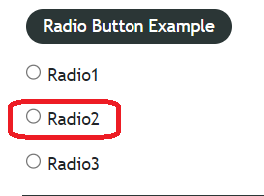

1. **ENTER TEXT INTO TEXT BOX**

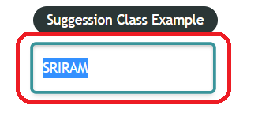

1. **SELECT DROPDOWN VALUE OPTION-2**

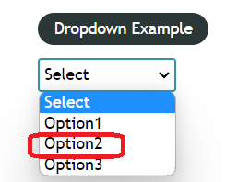

1. **SELECT CHECKBOX 2**

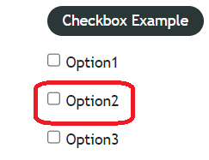

1. **CLICK ON OPEN WINDOW BUTTON AND GET TITLE OF NEW WINDOW AND VALIDATE**

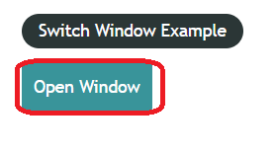

1. **CLICK ON OPEN TAB BUTTON AND GET TITLE OF NEW TAB AND VALIDATE**

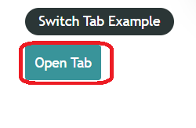

1. **ENTER YOUR NAME IN TEXT BOX THEN CLICK ON ALERT THEN CLICK ON OK BUTTON IN ALERT**

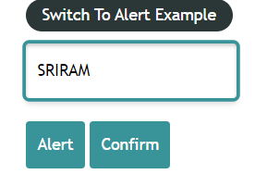

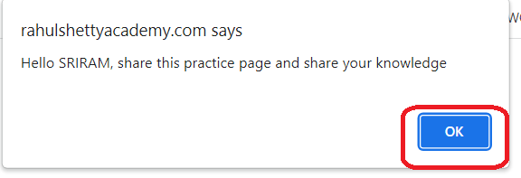

1. **ENTER YOUR NAME IN TEXT BOX THEN CLICK ON CONFIRM THEN CLICK ON CANCEL BUTTON IN ALERT**

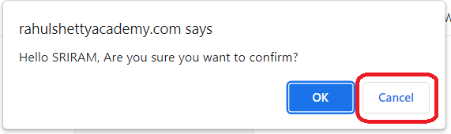

1. **1. READ ALL PRICE DETAILS FROM TABLE**
2. **READ ENTIRE ROW ONLY FOR WHOS PRICE IS 35**

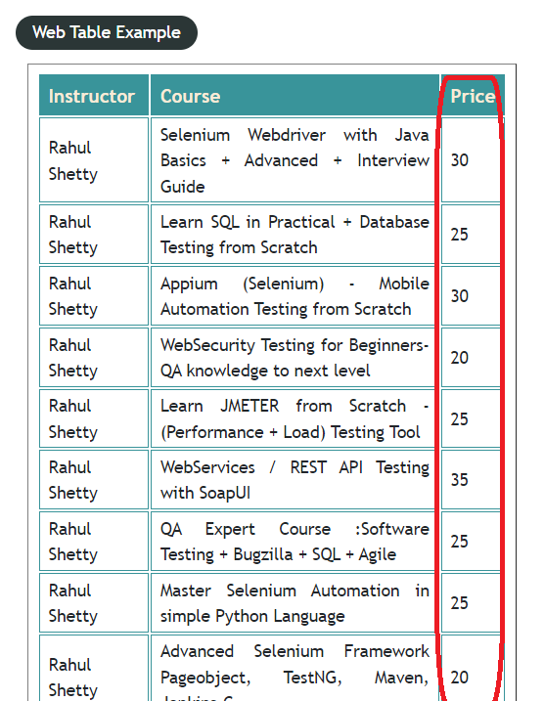

1. **READ ALL THE NAMES FROM TABLE**

